**Beet Sprout — детальніше заглибся в практику.**

1. В Google docs створи 5 тест-кейсів для функціонального тестування сайту <https://automoto.ua/uk/>

| **TC 1: Selecting and checking a car using the "Order" button in the website header.** | | | |
| --- | --- | --- | --- |
| **prerequisites: https://automoto.ua/uk/pidbir-auto  Google Chrome 109.0.5414.120** | | | |
|  | Step Details | Test Data | Expected Results |
| 1 | Click the "Order" button in the website header. |  | Opens the services and application form. |
| 2 | Scroll to the application form. |  |  |
| 3 | Fill in the checkboxes from the parameters. |  |  |
| 4 | Complete the "Phone number" field. |  | The application has been sent. Message: "Wait for a call from the manager". |
|  |  |  |  |
| **TC 2: View a list of all ads posted on the site.** | | | |
| **prerequisites: https://automoto.ua/uk/pidbir-auto  Google Chrome 109.0.5414.120** | | | |
|  | Step Details | Test Data | Expected Results |
| 1 | Click on the active link "Total ads found:" on the main page. |  | The first page of messages opens. |
| 2 | Scroll to the Pagination element. |  | Here are the first five pages of ads for the Pagination element. |
| 3 | Click on the next page of ads. |  | The second page of ads opens. |
| 4 | Navigate through the ad pages. |  | All ad pages open. |
|  |  |  |  |
| **TC 3: Search for a car with advanced search.** | | | |
| **prerequisites: https://automoto.ua/uk/pidbir-auto  Google Chrome 109.0.5414.120** | | | |
|  | Step Details | Test Data | Expected Results |
| 1 | Click on the "Advanced Search" button on the main page. |  | The advanced search form opens. |
| 2 | Select the "Transport type" in the dropdown. |  | Select the required type from the list. |
| 3 | Complete the "Car body type" checkboxes. |  | Select the preferred checkboxes. |
| 4 | Choose the "Car brand" in the dropdown. |  | Select the required car brand from the list. |
| 5 | Complete other parameters of the extended list as needed. |  | Possible advanced search fields: model, year of manufacture, price, mileage, condition, specifications, additional options, and region of base. |
| 6 | Click the Show button. |  | Ads are opened according to the specified advanced search parameters. |
|  |  |  |  |
| **TC 4: View the car catalog by region.** | | | |
| **prerequisites: https://automoto.ua/uk/pidbir-auto  Google Chrome 109.0.5414.120** | | | |
|  | Step Details | Test Data | Expected Results |
| 1 | Scroll to "Catalog by region" on the main page. |  | The list of regions appears. |
| 2 | Click on the required region. | Zaporizhzhia | Classifieds for sale of cars in Zaporizhzhia. |
| 3 | Scroll to the Pagination element. |  | Here are the first five pages of ads for the Pagination element. |
| 4 | Click on the next page of ads. |  | The second page of ads opens. |
| 5 | Navigate through the ad pages. |  | All ad pages open. |
|  |  |  |  |
| **TC 5: Submit your feedback/questions.** | | | |
| **prerequisites: https://automoto.ua/uk/pidbir-auto  Google Chrome 109.0.5414.120** | | | |
|  | Step Details | Test Data | Expected Results |
| 1 | Click "Contacts" in the footer of the site. |  | Contacts and the "Leave a comment/question" form open. |
| 2 | Complete the form: name, phone number, email. |  |  |
| 3 | Complete the "Message" field. |  |  |
| 4 | Attach the file if necessary. |  | The form is complete (all fields are highlighted in green). |
| 5 | Click the "Send" button. |  | Question/feedback successfully sent : "Thank you, your message has been received. Please wait for a reply from a support representative." |

2. За допомогою <https://reqbin.com/> протестуйнаступні методи API [Reqres](https://reqres.in/):

* LIST USERS
* SINGLE USER
* CREATE
* UPDATE (PUT)
* UPDATE (PATCH)
* DELETE
* REGISTER - SUCCESSFUL
* LOGIN - SUCCESSFUL

Створи документ, в якому у довільному форматі, але зі скриншотами, опиши знайдені баги. Документ додай до LMS.

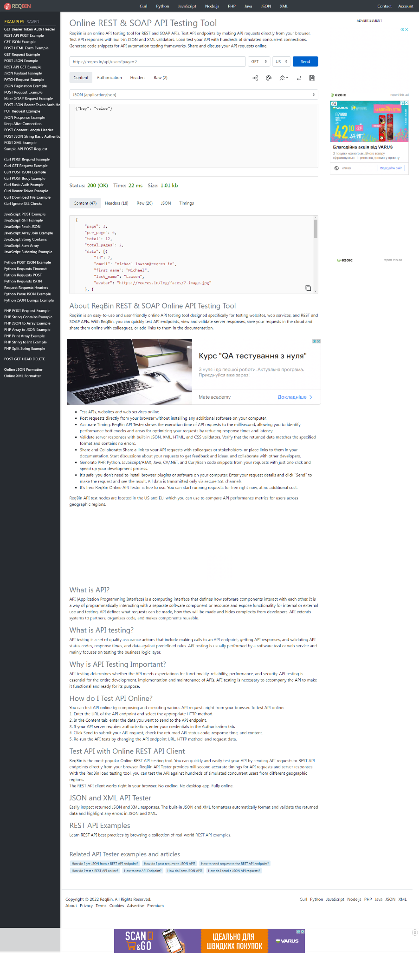

Баг: Зробила запит на сторінку 77, код відповіді: "200 OK", але сторінок всього 2, та очікуваний результат повин бути код: "404 Not Found"

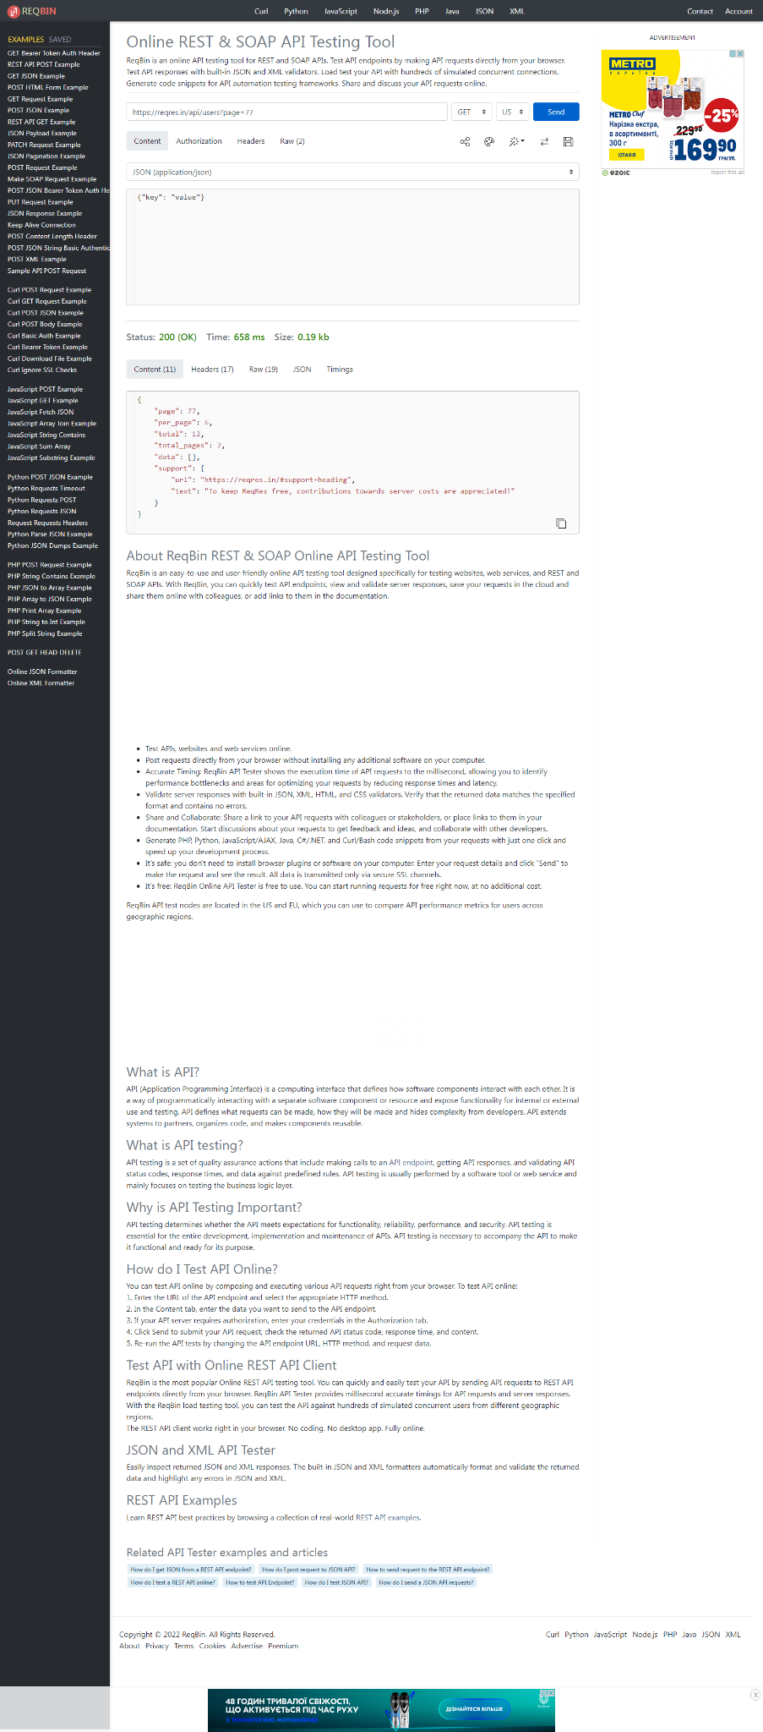

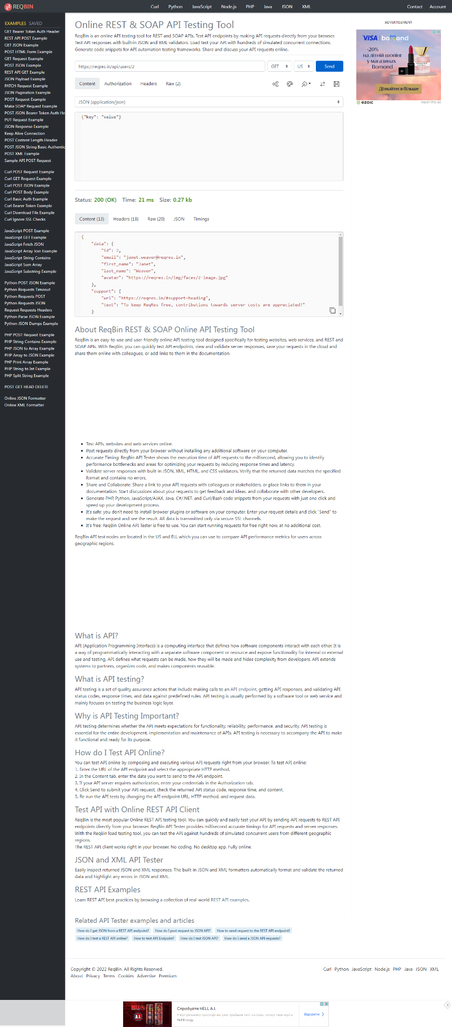

Баг: CREATE створила користувача без {"name":,"job":}. Очікуваний ркзультат код :”400 Bad Request”

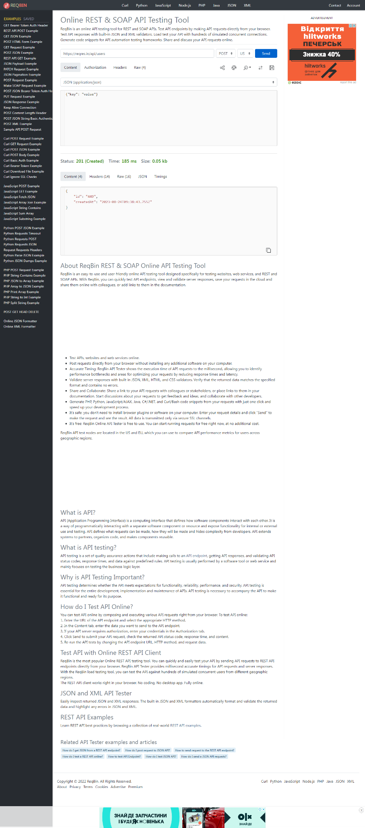

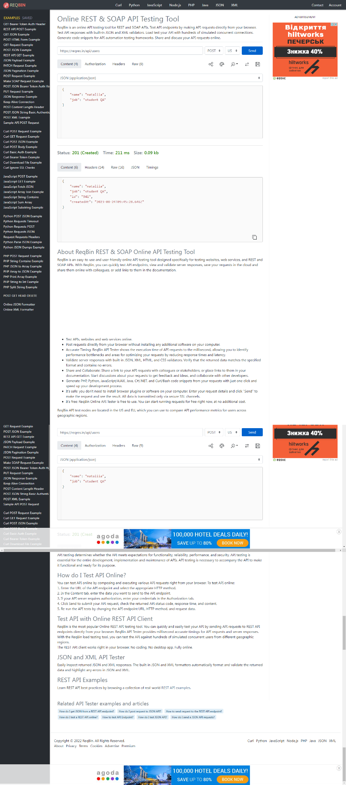

Баг: UPDATE через метод PUT невказані дані. Очікуваний ркзультат код :”400 Bad Request”

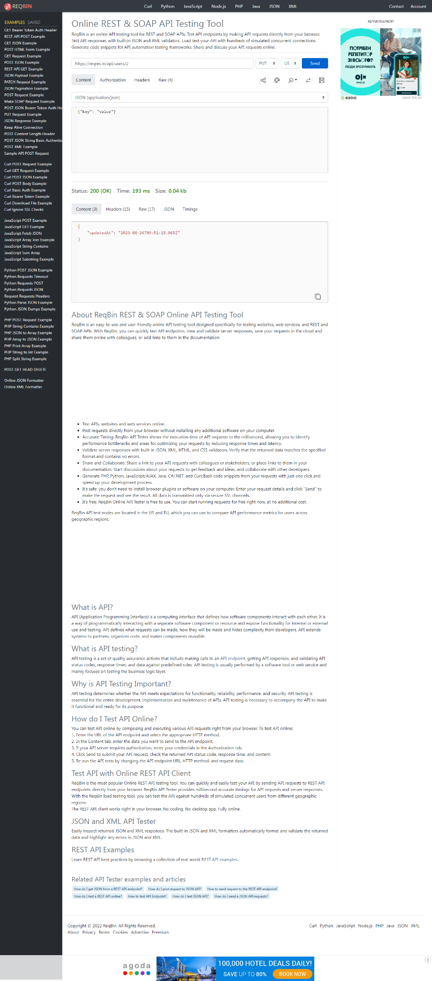

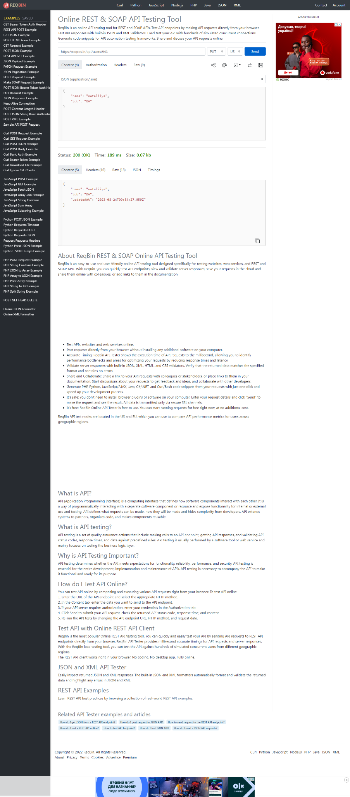

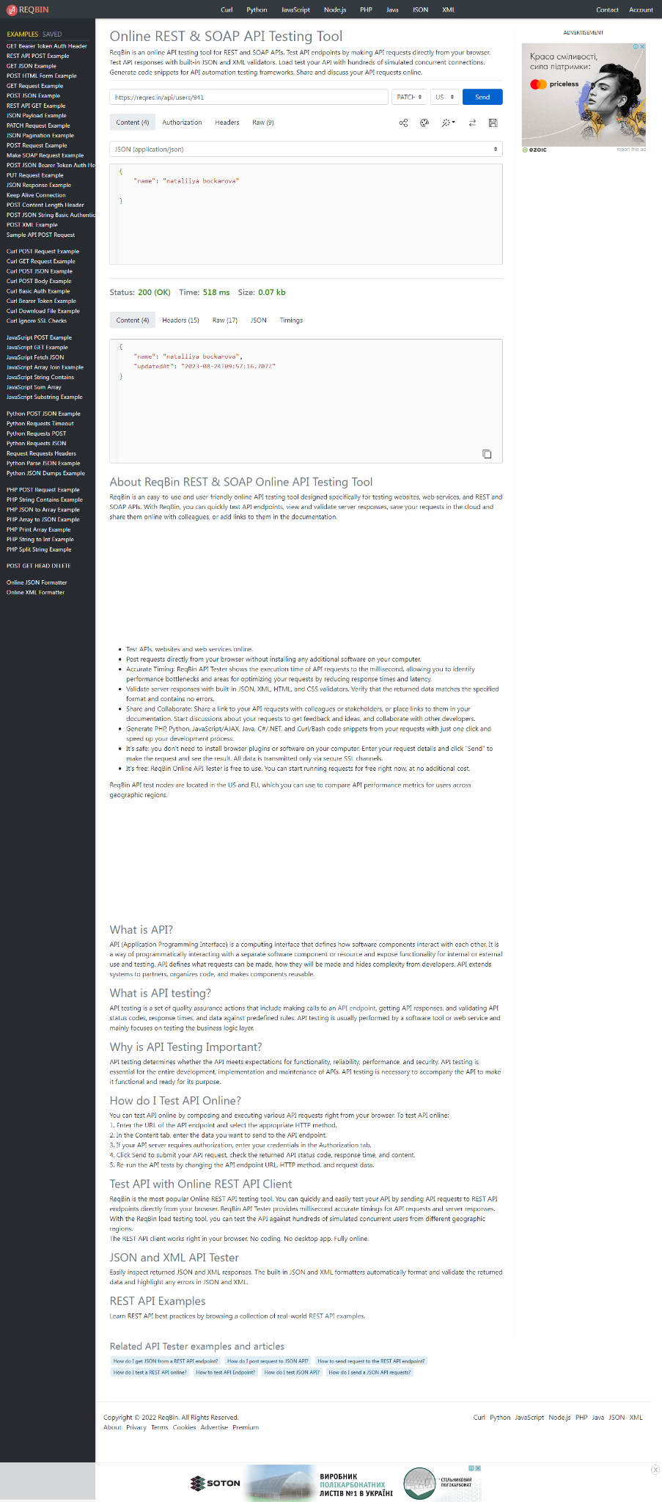

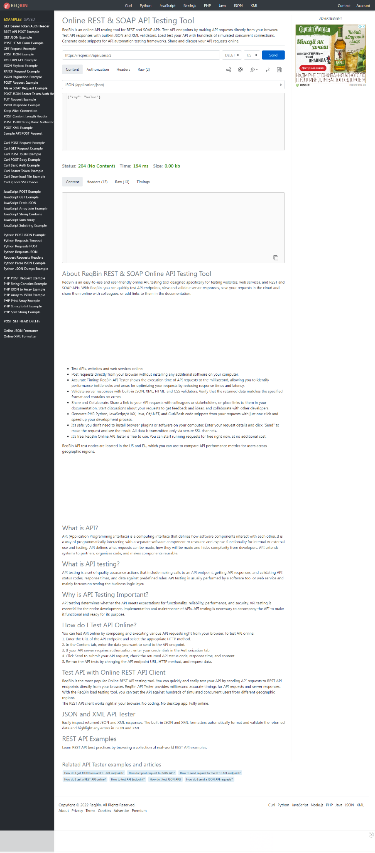

Баг: DELETE користувача 20, якого не існує (їх всього 12). Очікуваний ркзультат код :”400 Bad Request”

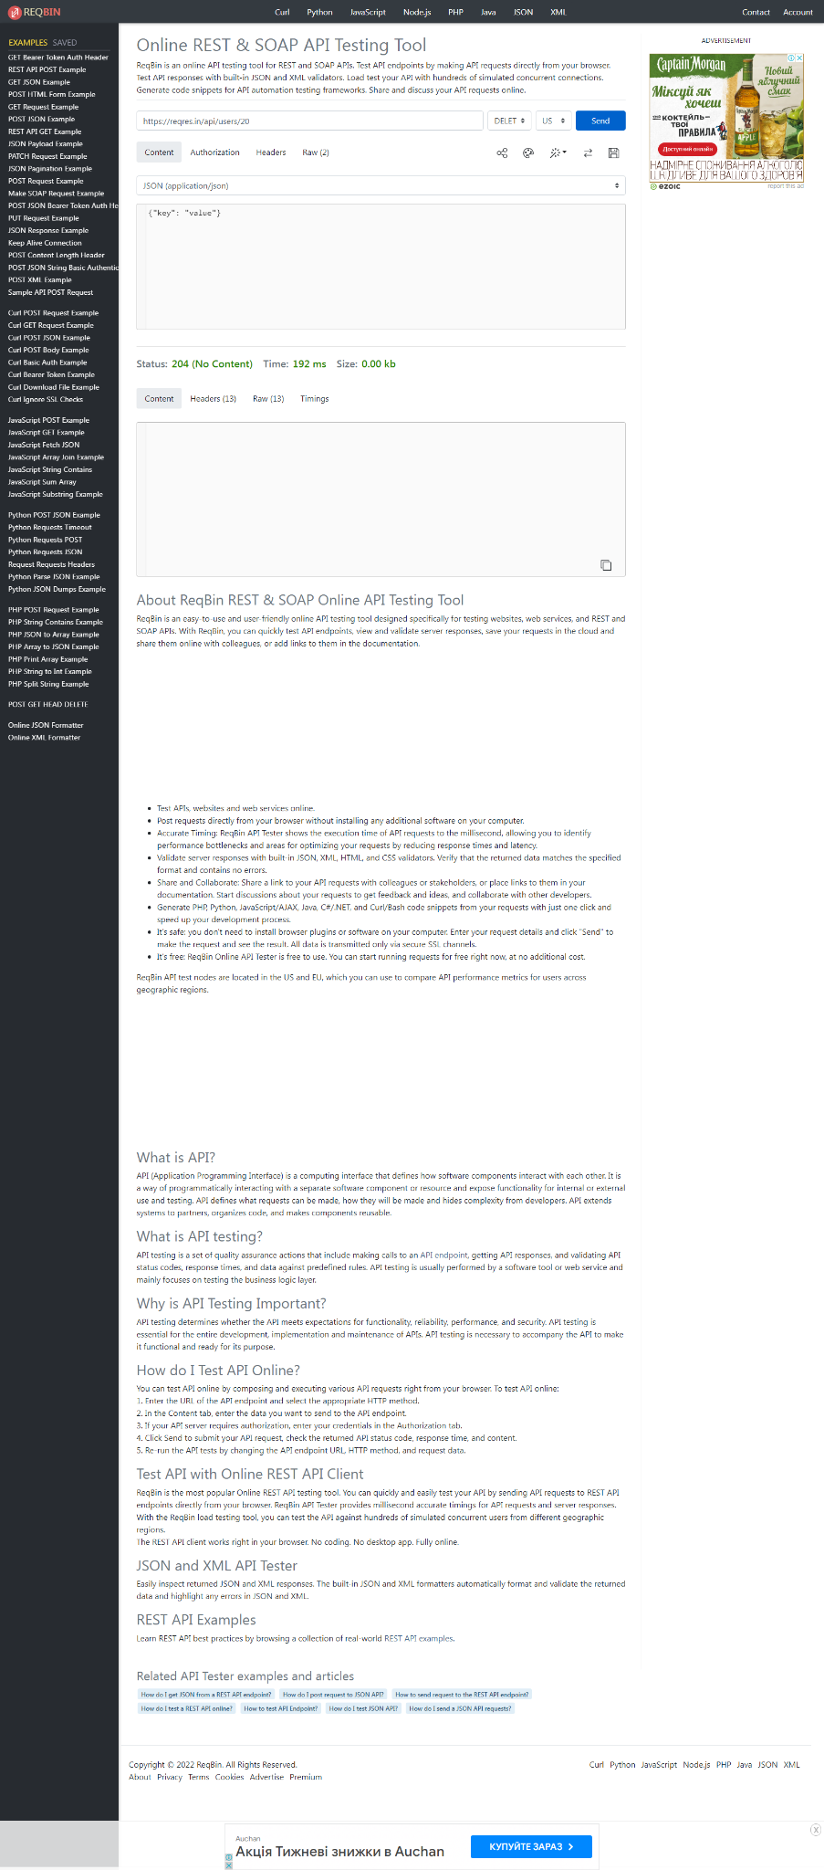

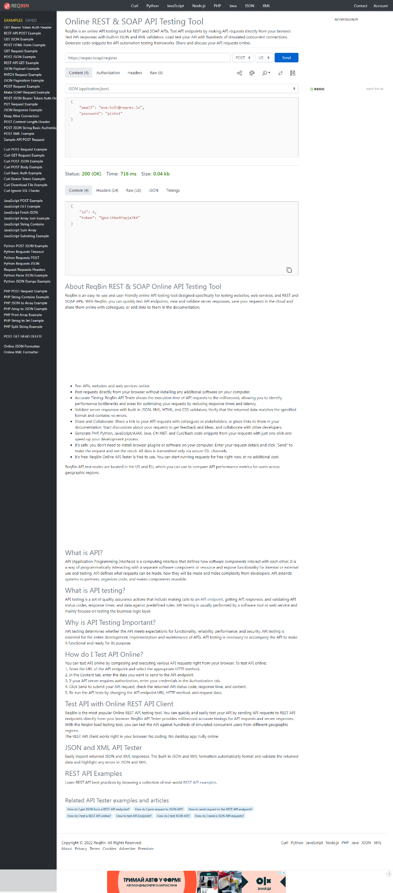

Коректна робота, не відбулася регістрація без паролю:

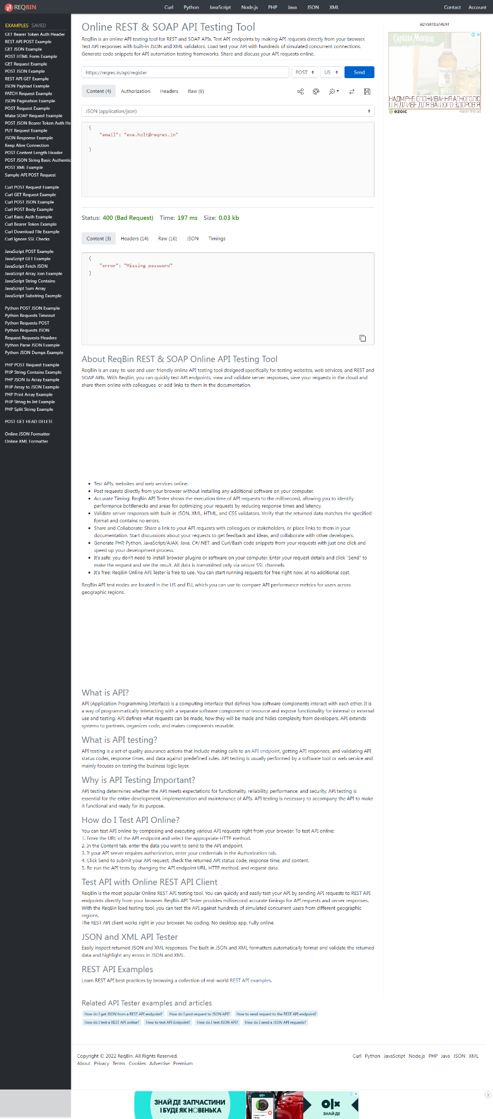

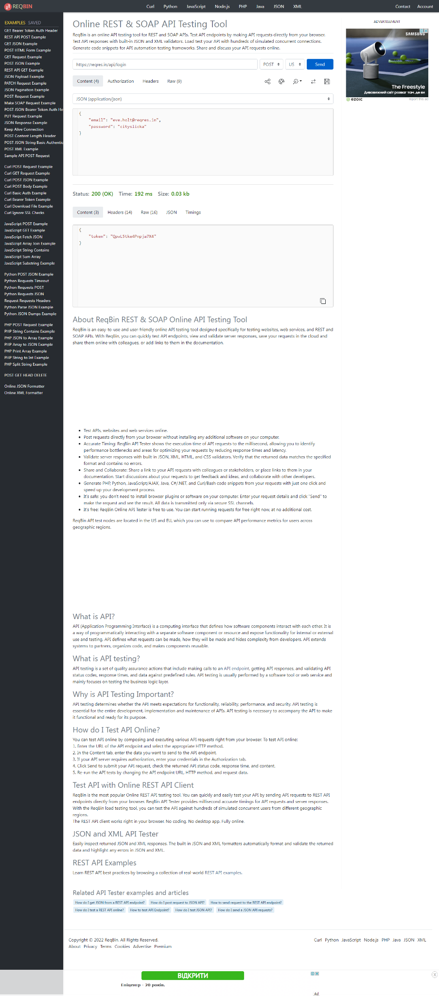

Коректна робота, не залогінилися без паролю:

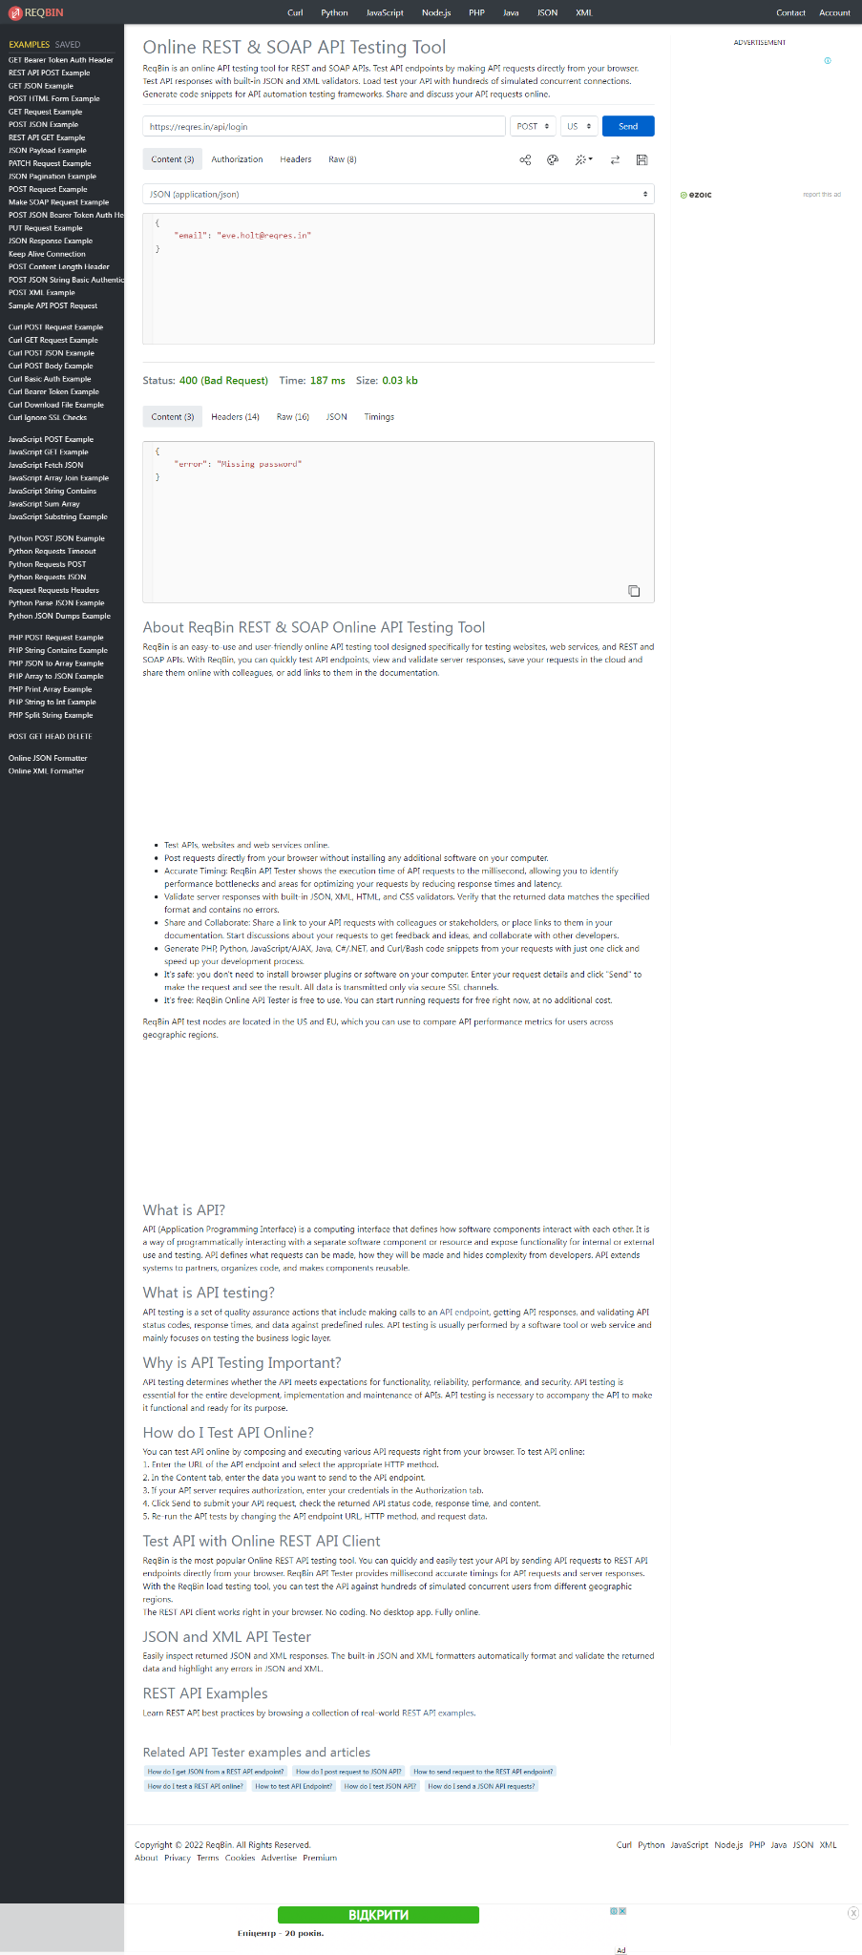

**Mighty Beet — різнобічно опануй тематику уроку.**

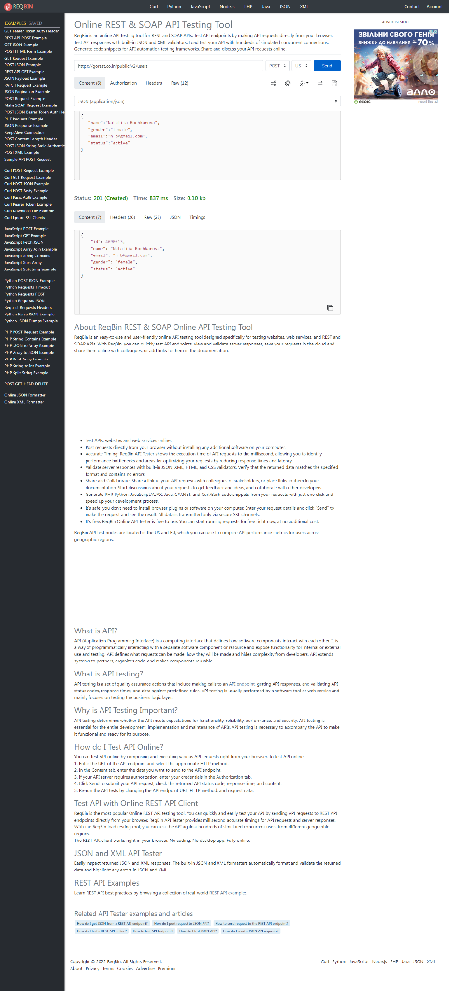

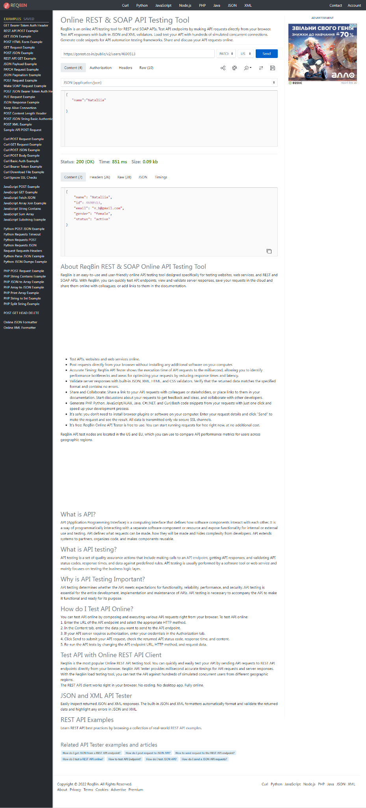

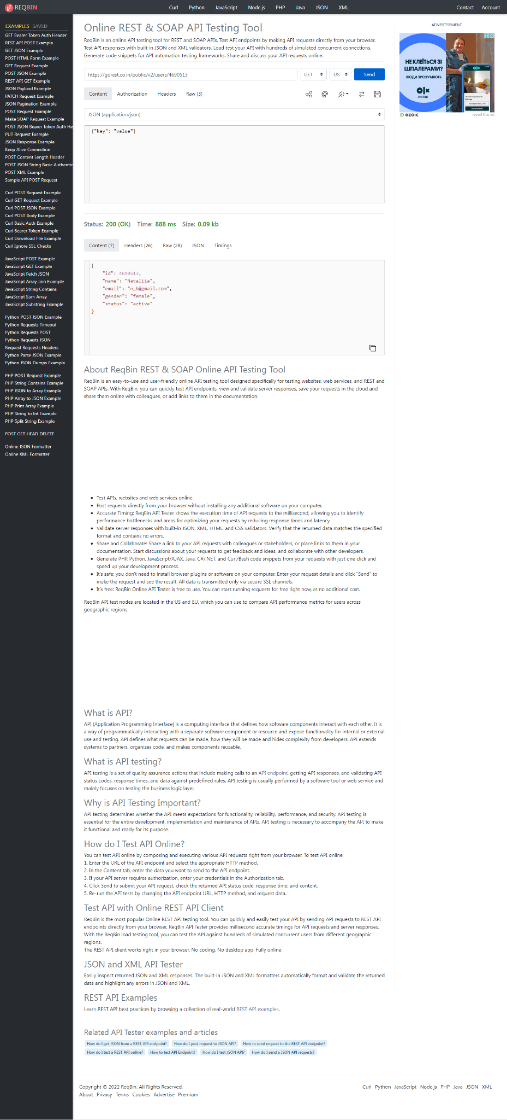

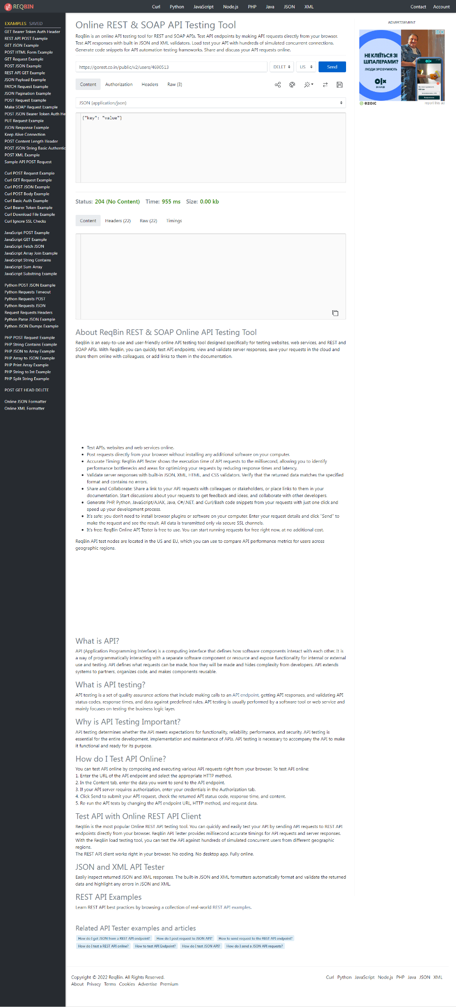

За відправки запиту **GET** порівняй його деталі, введені у <https://reqbin.com/> і відображені в **Developer Tools**.

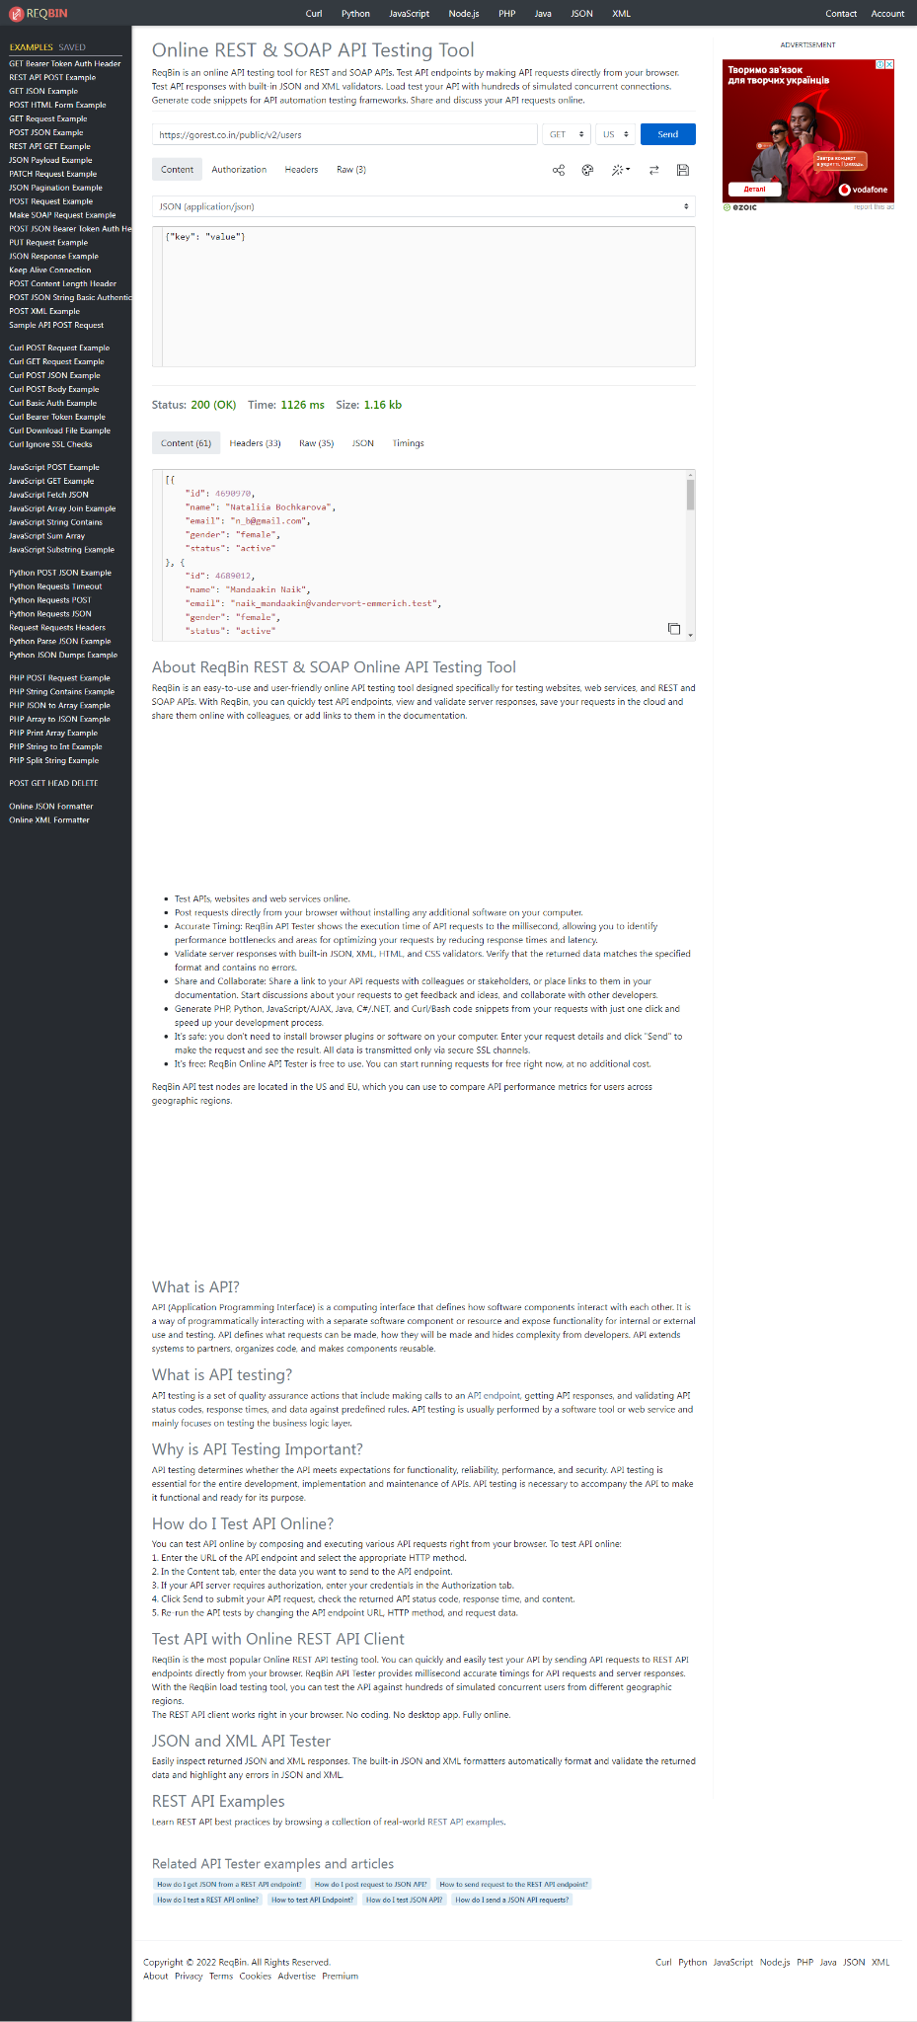

**Developer Tools:**

[{"id":4690970,"name":"Nataliia Bochkarova","email":"n_b@gmail.com","gender":"female","status":"active"},{"id":4689012,"name":"Mandaakin Naik","email":"naik_mandaakin@vandervort-emmerich.test","gender":"female","status":"active"},{"id":4689011,"name":"Kumar Sinha","email":"sinha_kumar@schultz.test","gender":"male","status":"active"},{"id":4689007,"name":"Rep. Chandni Adiga","email":"chandni_rep_adiga@gusikowski.test","gender":"male","status":"active"},{"id":4689005,"name":"Indra Tagore DVM","email":"indra_tagore_dvm@emmerich-vandervort.test","gender":"female","status":"inactive"},{"id":4689004,"name":"Bhoopat Pothuvaal","email":"pothuvaal_bhoopat@stracke-leuschke.example","gender":"female","status":"active"},{"id":4689003,"name":"Agrata Kaniyar","email":"kaniyar_agrata@keeling.test","gender":"female","status":"active"},{"id":4689002,"name":"Rev. Inder Kaul","email":"kaul_rev_inder@volkman-bosco.test","gender":"male","status":"active"},{"id":4689001,"name":"Rukhmani Bhat","email":"rukhmani_bhat@block.test","gender":"female","status":"inactive"},{"id":4689000,"name":"Amaresh Dubashi DDS","email":"dubashi_amaresh_dds@feest-goldner.test","gender":"male","status":"inactive"}]

Запити співпадають.